Pizza Sales SQL Queries

A
1. Total revenue

SELECT SUM(total_price) AS Total_Revenue FROM pizza_sales_
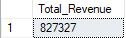
2.Average order value

SELECT CAST(SUM(total_price) AS FLOAT)/CAST(COUNT(DISTINCT order_id)AS FLOAT) AS Avg_Order_Val FROM pizza_sales_
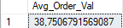

3.Total pizzas sold

SELECT SUM(quantity) AS Total_Pizza_Sold FROM pizza_sales_
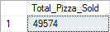

4.Total orders

SELECT COUNT(DISTINCT order_id) AS Total_orders FROM pizza_sales_
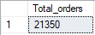

5.Average pizzas per order

SELECT CAST(SUM(quantity) AS FLOAT)/CAST(COUNT(DISTINCT order_id) AS FLOAT) AS Avg_Pizza_per_Order FROM pizza_sales_
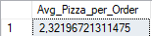

SELECT DATENAME(DW,order_date) AS Order_Day, COUNT(DISTINCT order_id) AS Total_Orders FROM pizza_sales_
GROUP BY DATENAME(DW,order_date)

B
1.Daily total orders

SELECT DATENAME(DW,order_date) AS Order_Day, COUNT(DISTINCT order_id) AS Total_Orders FROM pizza_sales_
GROUP BY DATENAME(DW,order_date)
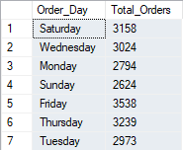

2.Monthly total orders

SELECT DATENAME(MONTH,order_date) AS Month, COUNT(DISTINCT order_id) AS Total_Orders FROM pizza_sales_
GROUP BY DATENAME(MONTH,order_date)

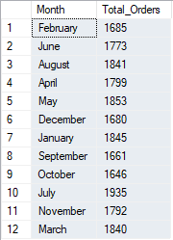

3.Percentage of sales by pizza category

SELECT pizza_category, SUM(total_price) AS Total_Revenue,
CAST(CAST(sum(total_price)*100 AS FLOAT)/(SELECT sum(total_price) FROM pizza_sales_)AS DECIMAL(10,2)) AS Perc_Sales
FROM pizza_sales_
GROUP BY pizza_category
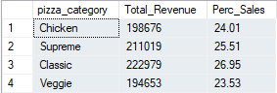

4.Percentage of sales by pizza size

SELECT pizza_size, SUM(total_price) AS Total_Revenue,
CAST(CAST(sum(total_price)*100 AS FLOAT)/(SELECT sum(total_price) FROM pizza_sales_)AS DECIMAL(10,2)) AS Perc_Sales
FROM pizza_sales_
GROUP BY pizza_size
ORDER BY Perc_Sales DESC
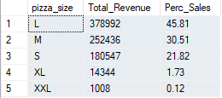

5.Total pizzas sold by pizza category

SELECT pizza_category, SUM(quantity) as Total
FROM pizza_sales_
GROUP BY pizza_category
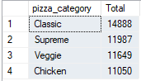
ORDER BY Total DESC

C
1.Top 5 pizzas sold by total revenue

SELECT TOP 5 pizza_name, SUM(total_price) AS Total_Revenue FROM pizza_sales_
GROUP BY pizza_name
ORDER BY Total_Revenue DESC
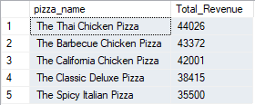

2.Bottom 5 pizzas sold by total revenue

SELECT TOP 5 pizza_name, SUM(total_price) AS Total_Revenue FROM pizza_sales_
GROUP BY pizza_name
ORDER BY Total_Revenue ASC
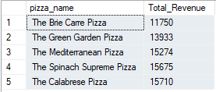

3.Top 5 pizzas sold by total quantity

SELECT TOP 5 pizza_name, SUM(quantity) AS Total_quantity FROM pizza_sales_
GROUP BY pizza_name
ORDER BY Total_quantity DESC
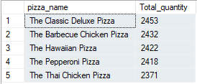

4.Bottom 5 pizzas sold by total quantity

SELECT TOP 5 pizza_name, SUM(quantity) AS Total_quantity FROM pizza_sales_
GROUP BY pizza_name
ORDER BY Total_quantity ASC
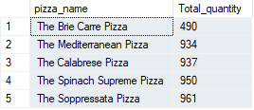

5.Top 5 pizzas sold by total orders

SELECT TOP 5 pizza_name, COUNT(DISTINCT order_id) AS Total_Orders FROM pizza_sales_
GROUP BY pizza_name
ORDER BY Total_Orders DESC
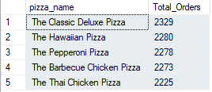

5.Bottom 5 pizzas sold by total orders

SELECT TOP 5 pizza_name, COUNT(DISTINCT order_id) AS Total_Orders FROM pizza_sales_
GROUP BY pizza_name
ORDER BY Total_Orders ASC
